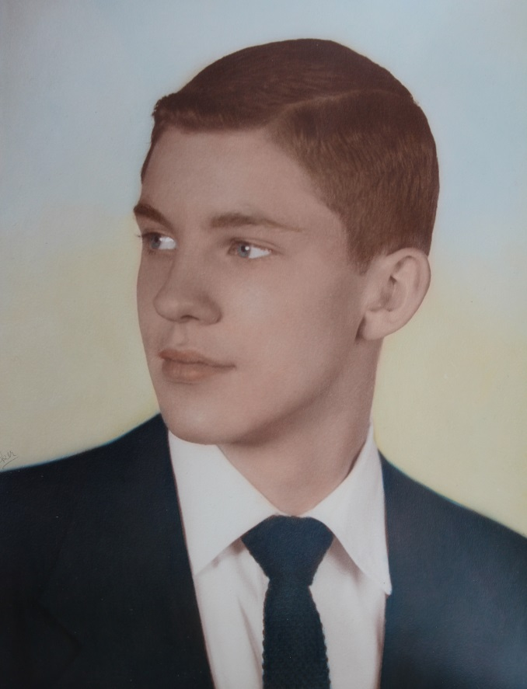

**David Wolfe List – 1953**

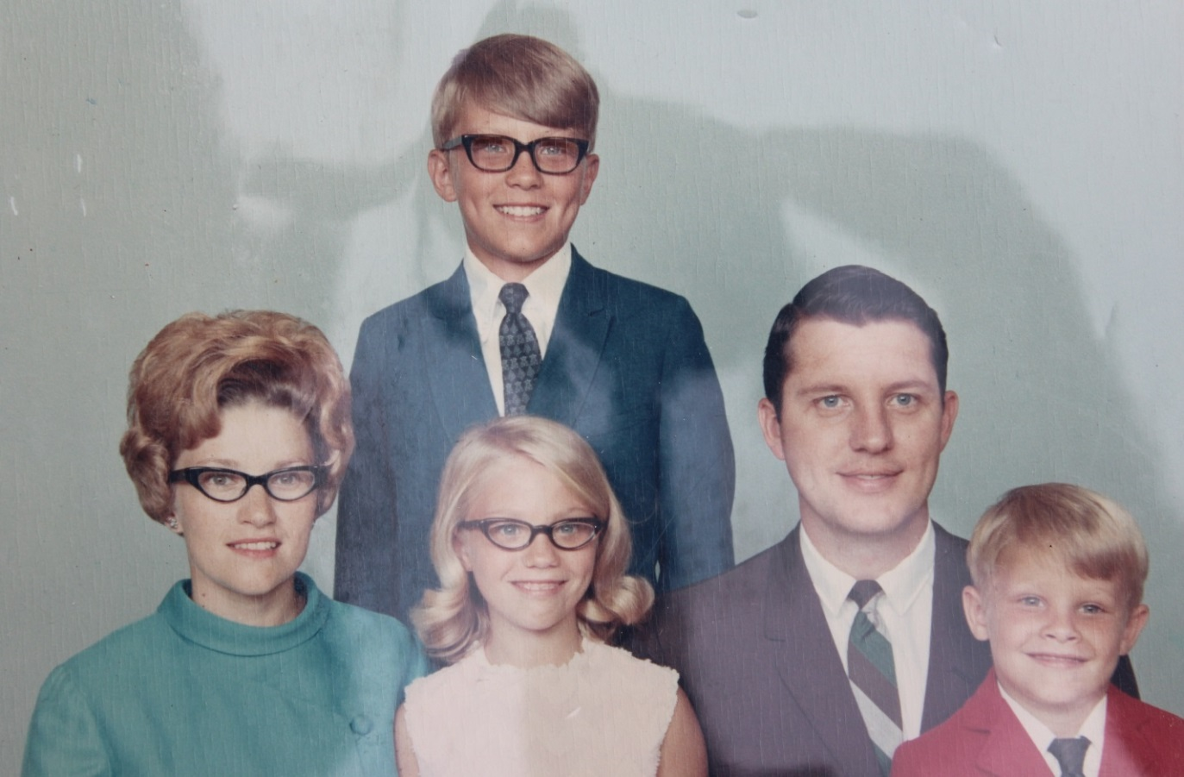

**l-r: Carolyn, Ann Elizabeth, David Wolfe, Brent Allen; David John (in rear) - all Lists – about 1970**